What Cold start Problem is?

Suppose you get a new user who join the environment and you want to recommend something to him.

Or you get a new product so how you recommend it to any user.

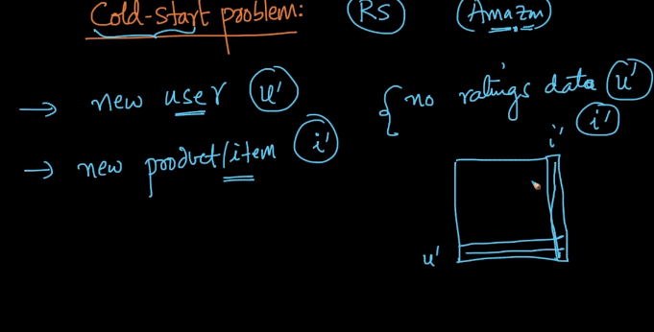

Lets go case by case.

SO when new user joins the environment u get his geolocation and device details based on the IP address which is very useful .

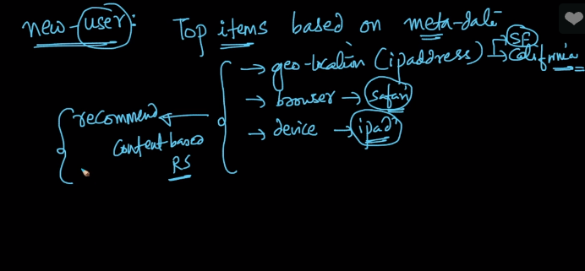

Similar is the case with new product i.e. based on its raw details i.e. category, price and description we can recommend it with similar feature product.

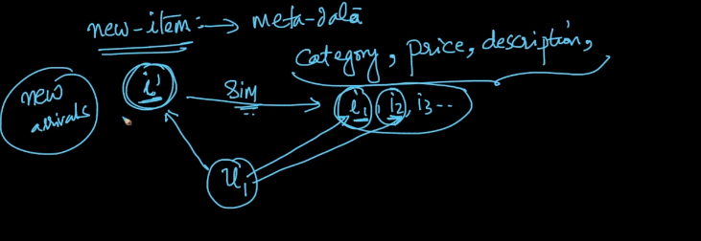

So this is called cold start problem which we can overcome by making content based recommendation system.

**Comments:**

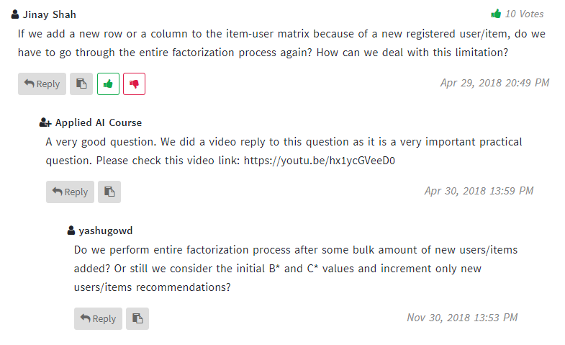

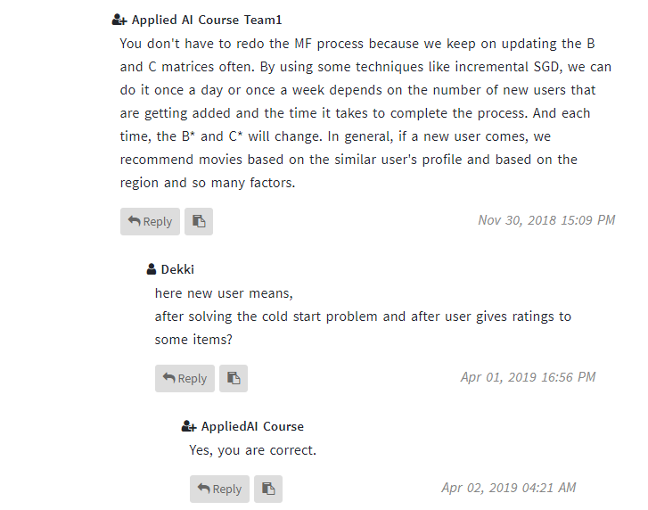

**Link to answer of above asked question:** <https://youtu.be/hx1ycGVeeD0>

